Fast**National University of Computer & Emerging Sciences, Karachi  
Spring-2022 CS-Department  
Quiz # 3   
23rd May, 2022**

|  |  |
| --- | --- |
| **Course Code: CS3005** | **Course Name: Theory of Automata** |
| **Instructor Name: Mr. Musawar Ali** | |
| **Student Roll No:** | |

**Instructions:**

* Return the question paper.
* Attempting of the question in the given order is highly encouraged.
* Read each question completely before answering it. There are **4 questions on 1 page.**
* In case of any ambiguity, you may make assumption. But your assumption should not contradict any statement in the question paper.
* **Show full steps and provide appropriate reasons wherever possible to get full credit.**

**Time: 60 minutes. Max Marks: 80 points**

**Question 1: Ambiguity in CFGs (10) Points**

Check for ambiguity in the given CFG for the string “**zbyy**”.

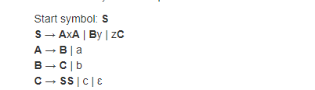

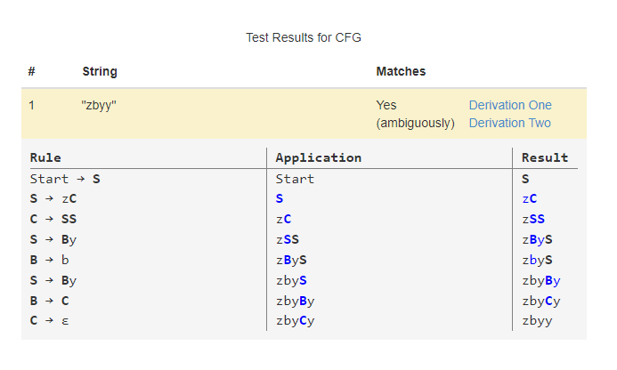

CFG is ambigious.

**Question 2: Simplification and CNF (10+10) Points**

Simplify the following CFG and convert it into CNF.

**Note:** show the steps clearly in rectangle boxes, put your simplified CFG and final CFG, converted into CNF in rectangle boxes to get full credit.

S🡪AxA|By|zC

A🡪B | a

B 🡪C|b

C🡪SS|c|

**Remove C🡪**

S🡪AxA|By|zC|z

A🡪B | a

B🡪C| |b

C🡪SS|c

**Remove B🡪**

S🡪AxA|By|y|zC|z

A🡪B|a|

B🡪C|b

C🡪SS|c

**Remove A🡪λ**

**S🡪** AxA|Ax|xA|x|By|y|zC|z

A🡪B|a

B🡪C|b

C🡪SS|c

**Remove B🡪C**

S🡪 AxA|Ax|xA|x|By|y|zC|z

A🡪B|a

B🡪SS|b|c

C🡪 SS|c

**Remove A🡪B**

S🡪 AxA|Ax|xA|x|By|y|zC|z

A🡪SS|b|c|a

B🡪SS|b|c

C🡪SS|c

**Simplified now**

Towards CNF

Put X🡪x, Y🡪y, Z🡪z, W🡪AX

S🡪 WA|AX|XA|x|BY|y|ZC|z

A🡪SS|b|c|a

B🡪SS|b|c

C🡪SS|c

X🡪x

Y🡪y

Z🡪z

W🡪AX

**Question 3: PDA (10+10) Points**

Draw the PDA for following languages.

$$L1=\left\{a^{n}b^{m}c^{m}d^{n} \right| n≥3,m≥0\} defined over alphabet Σ=\{a,b,c,d\}$$

$$L2=\left\{a^{n}b^{m}c^{n}\right|n≥m \& n,m≥0\} defined over alphabet Σ=\{a,b\}$$

**Question 4: CFG to PDA (10+ 10 + 10 Points)**

Convert following CFG into PDA. Give the instantaneous description of PDA. Trace the string ‘**aba**’ on the stack and show the steps clearly to get full credit.

S🡪a | Xb|aa|aYa|b

X🡪Y

Y🡪b|x